**A**

**PROJECT REPORT**

**ON**

**“Offline Subject Notes App”**

**SUBMITTED TO**

**SHIVAJI UNIVERSITY, KOLHAPUR**

**IN THE PARTIAL FULFILLMENT OF THE REQUIREMENT**

**FOR THE AWARD OF DEGREE**

**BACHELOR OF TECHNOLOGY IN COMPUTER SCIENCE AND ENGINEERING**

**SUBMITTED BY**

|  |  |  |
| --- | --- | --- |
| **MISS.** | **AISHWARYA NAGESH KALE** | **23UAD302** |

**UNDER THE GUIDANCE OF**

**Mr. S. P. Pise**

** **



**DEPARTMENT OF ARTIFICIAL INTELLIGENCE AND DATA SCIENCE ENGINEERING**

**DKTE SOCIETY’S TEXTILE AND ENGINEERING INSTITUTE, ICHALKARANJI**

**(AN EMPOWERED AUTONOUMOUS INSTITUTE)**

**2024-2025**

**D.K.T.E. SOCIETY’S**

**TEXTILE AND ENGINEERING INSTITUTE, ICHALKARANJI**

**(AN EMPOWERED AUTONOUMOUS INSTITUTE)**

**DEPARTMENT OF ARTIFICIAL INTELLIGENCE AND DATA SCIENCE ENGINEERING**



**CERTIFICATE**

**This is to certify that, project work entitled**

**“Offline Subject Notes App”**

**is a bonafide record of project work carried out in this college by**

|  |  |  |
| --- | --- | --- |
| **MISS.** | **AISHWARYA NAGESH KALE** | **23UAD302** |

**is in the partial fulfillment of award of degree Bachelor of Technology in Artificial Intelligence and Data Science Engineering prescribed by Shivaji University, Kolhapur for the academic year 2024-2025.**

**MR. S. P. PISE**

**(PROJECT GUIDE)**

**PROF. (DR.) T. I. BAGBAN PROF.(DR.) L.S.ADMUTHE**

**(HOD AI & DS DEPT.) (DIRECTOR)**

**EXAMINER: ________________**

**DECLARATION**

**We hereby declare that, the project work report entitled “Offline Subject Notes App” which is being submitted to D.K.T.E. Society’s Textile and Engineering Institute Ichalkaranji, affiliated to Shivaji University, Kolhapur is in partial fulfillment of degree B.Tech.(AI & DS). It is a bonafide report of the work carried out by us. The material contained in this report has not been submitted to any university or institution for the award of any degree. Further, we declare that we have not violated any of the provisions under Copyright and Piracy / Cyber / IPR Act amended from time to time.**

|  |  |  |  |
| --- | --- | --- | --- |
| **Title** | **Name of the Student** | **PRN** | **Signature** |
| **MISS.** | **Aishwarya Nagesh Kale** | **23UAD302** |  |

**ACKNOWLEDGEMENT**

**With great pleasure we wish to express our deep sense of gratitude to Mr. S. P. Pise for his valuable guidance, support, and encouragement in the completion of this project report.**

**Also, we would like to take the opportunity to thank our head of department Dr. T. I. Bagban for his cooperation in preparing this project report.**

**We feel gratified to record our cordial thanks to other staff members of the Artificial Intelligence and Data Science Department for their support, help, and assistance which they extended as and when required.**

**Thank you,**

|  |  |  |
| --- | --- | --- |
| **Title** | **Name of the Student** | **PRN** |
| **MISS.** | **Aishwarya Nagesh Kale** | **23UAD302** |

**ABSTRACT**

**The Subject Notes App is an Android application for managing notes by subject with both online and offline support. It uses MySQL for cloud storage and Room, SQLite, and Shared Preferences for local access. Users can add, edit, delete, and search notes with a clean, user-friendly interface. The app follows a modular, scalable design using Java and XML. Agile and Incremental models guide its development for flexibility and efficiency. The primary goal is to deliver a high-performance, offline-first application that provides an organized and seamless platform for educational and personal note management.**

**INDEX**

1. **Introduction PgNo 01** 
   1. **Problem definition**
   2. **Aim and objective of the project**
   3. **Scope and limitation of the project**

1. **Background study and literature overview PgNo 02**
   1. **Literature overview**
   2. **Investigation of current project and related work**

1. **Requirement analysis PgNo 03**

**a. Requirement Gathering**

**b. Requirement Specification**

**c. Use case Diagram**

1. **System design PgNo 4 -5** 
   1. **Architectural Design**
   2. **Flow Chart**
   3. **System Modeling**

**Dataflow Diagram**

1. **Implementation PgNo 06**

**a. Agile Methodologies**

**b. Development Model**

1. **Future Scope PgNo 07**

1. **Output PgNo 8 - 9**
2. **References (Public repository GitHub source code links) PgNo 10**

**1. Introduction**

1. **Problem definition**

In today's digital world, students and professionals deal with large amounts of information. Traditional note-taking methods often lack proper structure, offline access, and subject-wise organization. This results in scattered and hard-to-find notes. Many apps require constant internet, making them unreliable in low-connectivity areas. Manual note management is time-consuming and inefficient. Users also face challenges in searching and organizing notes effectively. This project solves these problems with a subject-based Android app that works offline and ensures easy, organized, and fast access to notes anytime.

1. **Aim and objective of the project**

The aim of the project is to develop an Android-based mobile application, "Offline Subject Notes App," that enables users to create, organize, and manage their notes in a structured, subject-wise format.

**Objectives:**

* To provide subject-based categorization for notes.
* To support offline note creation, editing, and deletion.
* To synchronize notes with an online database when connectivity is available.
* To implement a search feature for quick access.
* To deliver a clean and responsive user interface.

1. **Scope and limitation of the project**

**Scope:**

* Android platform with support for smartphones and tablets.
* Integration of local storage (Room, SQLite) and server storage (MySQL).
* Support for CRUD operations on both subjects and notes.
* Search functionality across note titles and content.

**Limitations:**

* Platform dependent (Android only).
* No multimedia or file attachments in the initial version.
* User authentication not implemented in current scope.

**2. Background study and literature overview**

1. **Literature overview**

Several popular note-taking applications like Google Keep, Microsoft OneNote, and Evermore offer advanced features but are often too generic or complex for academic usage. They lack proper subject-based structuring and offline-first design, which are crucial for students and researchers.

These applications typically provide a flat note structure or rely heavily on cloud-based access, which can hinder productivity in network-constrained environments. Additionally, many require subscriptions for full functionality, making them less accessible to students. Their user interfaces are often cluttered, and do not support simple workflows such as classifying notes under academic subjects or managing offline edits easily.

1. **Investigation of current project and related work**

While applications like Notion and Simple note provide a degree of categorization, most don't natively support subject-level organization or seamless offline-to-online synchronization. Their flexibility in design often sacrifices simplicity, and syncing mechanisms may require third-party integrations or accounts.

Our app bridges this gap by combining simplicity with powerful classification and sync features tailored for academic and professional users. It eliminates complexity by focusing on essential features like subject-wise note categorization, offline editing, and automatic syncing, offering a lightweight and intuitive solution.

Furthermore, very few existing apps adopt a modular, offline-first architecture with Room DB and shared preferences as part of their native design. This architecture in our solution makes the app fast, responsive, and ideal for real-world use in schools, colleges, and workplaces where network issues can interrupt access to critical information.

**3. Requirement analysis**

1. **Requirement Gathering**

**Sources:**

* Feedback from students and academic professionals
* Analysis of existing apps and their shortcomings
* Mobile UI/UX design standards

1. **Requirement Specification**

**Functional Requirements:**

* User can add/edit/delete subjects.
* User can add/edit/delete notes under subjects.
* App stores data offline and syncs when online.
* Search feature for note content and titles.

**Non-Functional Requirements:**

* Responsive and smooth user interface
* Minimal resource consumption
* Scalable database structure
* Secure and reliable data handling

1. **Use case Diagram**

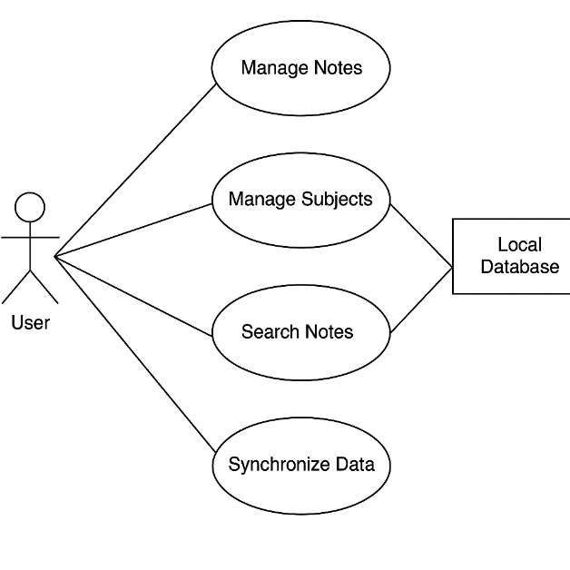

**4. System design**

1. **Architectural Design**

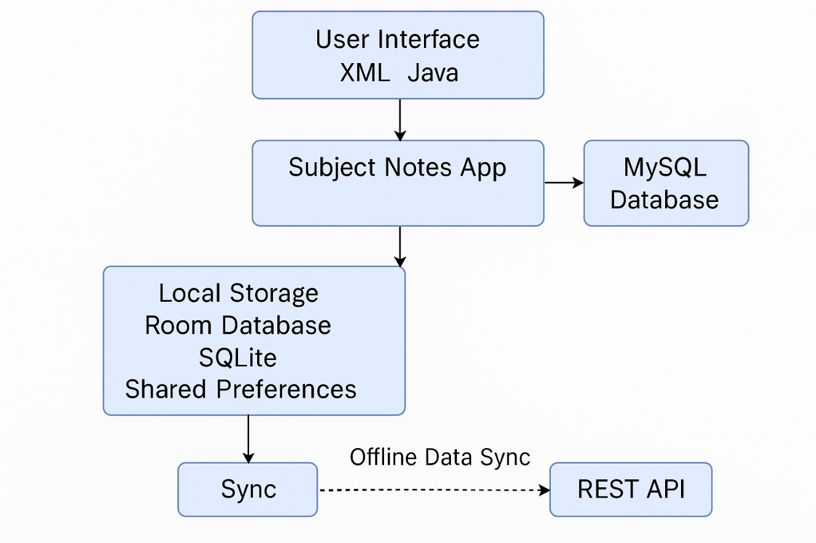

1. **Flow Chart**

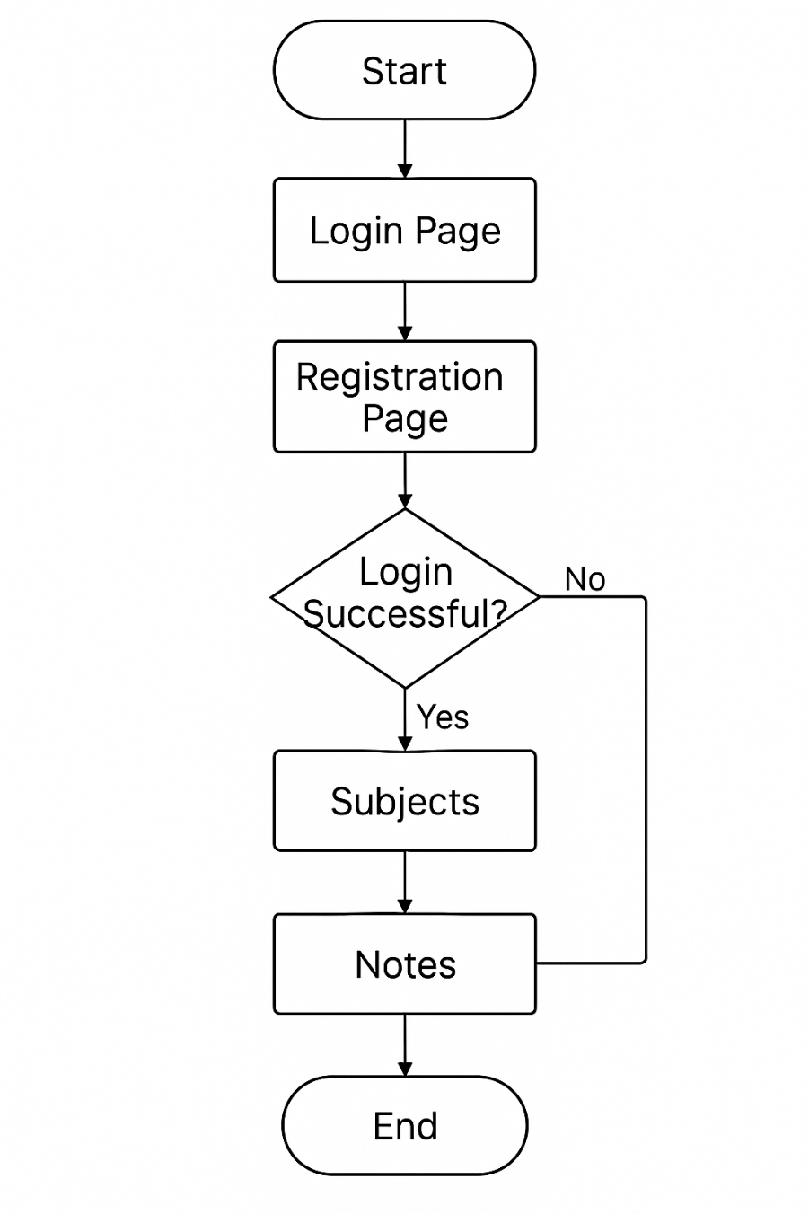

1. **System Modeling**
2. **Dataflow Diagram**

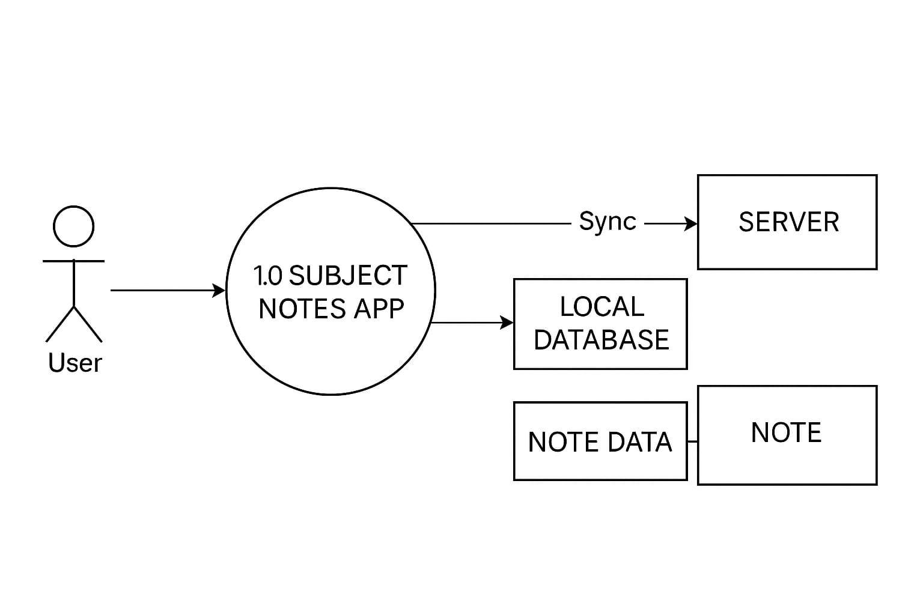

**5. Implementation**

1. **Agile Methodologies**

The app was developed using **Agile methodology**, ensuring flexibility, adaptability, and fast delivery. Work was divided into multiple **sprints**, with each sprint delivering a working feature such as the subject module, note CRUD functions, search, and sync.

Each feature was **individually tested** before integration, and **regular reviews** ensured that the development remained user-centric. This approach allowed for real-time feedback implementation, quick adaptation to changes, and continuous delivery of improvements.

The team maintained **daily stand-ups, sprint reviews, and retrospectives**, which enhanced collaboration and minimized bugs by ensuring consistent testing and improvements during each development cycle.

1. **Development Model**

The development of the app was aided by the implementation of various software development paradigms:

The Incremental model facilitated feature development step by step, making it easier to debug, develop in modules, and minimize risk. This facilitated gradual integration of each module such as subject management, notes CRUD operations, and search functionality.

The Agile model facilitated iterative development, supporting a flexible and user-centric nature. It supported evolving requirements and ensured constant improvement through sprint development.

The Prototype model was instrumental in testing the user interface and experience. Visual models were presented to users early on for feedback, which resulted in more effective design refinement prior to full-scale deployment.

The RAD (Rapid Application Development) model sped up the UI/UX development process using reusable components and brief development cycles. This was especially useful for deploying interface screens and testing them quickly.

**6. Future Scope**

* Add cloud storage support like Firebase
* Implement user login and authentication
* Enable PDF/text export and import of notes
* Extend to iOS and web platforms
* Use AI for smart suggestions and summaries

**7. Output**

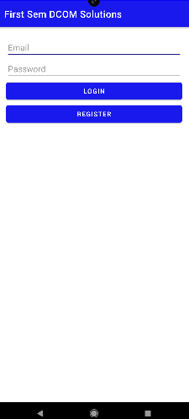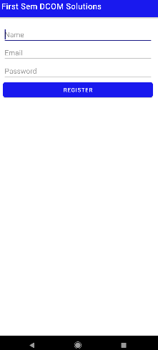

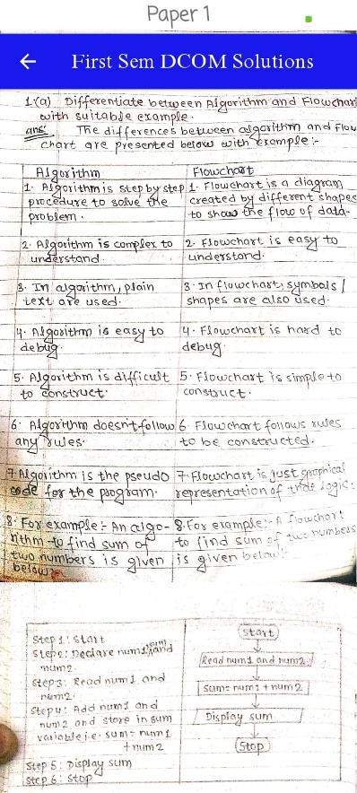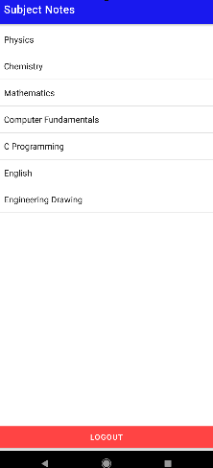

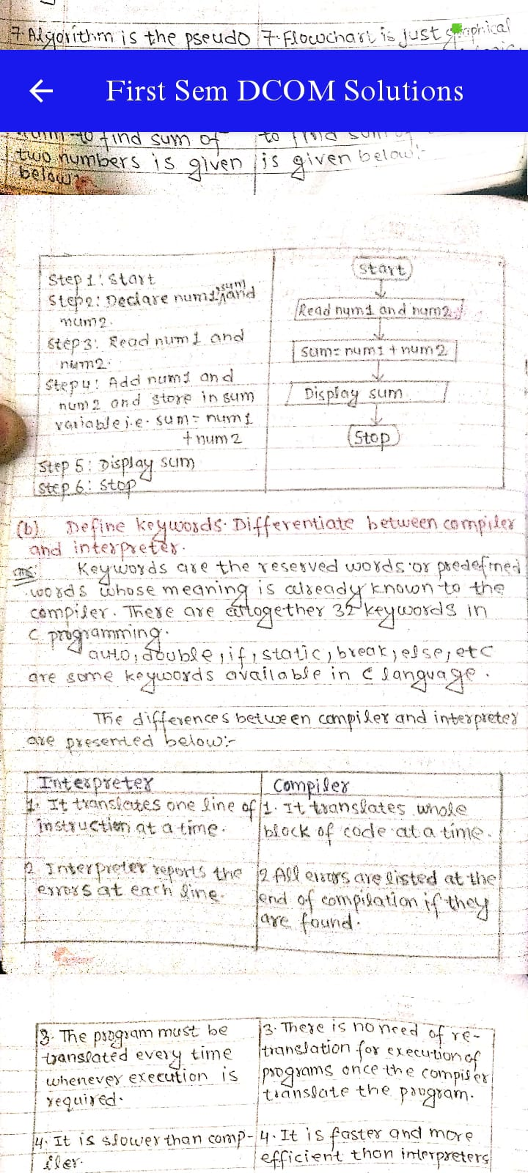

**8. References (public repository GitHub source code links)**

<https://developer.android.com/studio/write/app-link-indexing>

<https://www.geeksforgeeks.org/how-to-build-a-simple-notes-app-in-android/>

<https://github.com/android/nowinandroid>